SLEAP Protocol
This protocol is to use Social LEAP Estimates Animal Poses (SLEAP). This protocol assumes that you have already collected videos of your behavior, with at most 36,000 frames per video. This can be achieved by recording 20 min at 30 fps, or 10 min at 60 fps. In order to track if the skeletons switch during the predictions, it is recommended that the intruder tails are marked in sharpie.

SLEAP Installation
- Install the most recent version of anaconda to the computer if anaconda is previously not installed.
- Within the anaconda prompt paste the following
conda update -n base conda
conda install -n base conda-libmamba-solver
conda config --set solver libmamba
- Now create an environment and install SLEAP with the following line:
mamba create -y -n sleap -c conda-forge -c nvidia -c sleap -c anaconda sleap=1.3.4

To open/close the software terminal
- To open the SLEAP environment, open the anaconda and type: conda activate sleap
  - To open the GUI you can now type: sleap-label
- To close the app from the menu select File → Quit.
  - Make sure to close out of the environment by typing the following into the anaconda terminal: conda deactivate

Preprocessing videos
Before using any videos for an experiment (or to train a model), ensure the video recording is trimmed to be just the times of interest with no hands present. You should also rename the videos to make it easier to keep track of while in the GUI.
- In file explorer right click on video, select open with clipchamp.
- Split the video right when the intruder is placed in a cage (and experimenter hand out of view). There should be 2 videos now.
- Delete the first video and the visual gap.
- Export video as the highest quality
  - For training the HAH SLEAP model, 720p was used.
- Name video as ID_testtype_dateofrecording (eg. 1604_RI_091824)
- In explorer (under downloads) delete “made with clipchamp” from the end of the video file.
  - Save video in a folder on the desktop.

Generating a model (first time)
To generate a model, you need a pilot dataset that you do not plan to analyze for your paper. It is recommended to have 10-20 videos (~5min) that encompass the range of behavior you want to analyze. These will serve as your ‘pilot’ data for both SLEAP and Simba
- In the SLEAP GUI, select File → Make a new Project.
- On the right panel you will see Videos, Skeleton, Labeling Suggestions, Instances.
- Click on Videos → Add videos to add your initial pilot videos to the training set.
  - When importing videos, it is imperative all videos are imported with the same number of channels. Grayscale should have 1 channel, regular colors should have 3 channels. If videos are not imported in grayscale you will not be able to properly predict on videos.
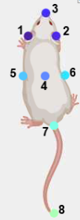
  - Check the videos file names, frame #, height, width, and channels. Videos should all be the same size and approximately the same length.
  - I started with just 3 videos in the project to make the initial labeling step easier.
- Define the skeleton (which body points you are tracking).
  - Click on Skeleton → Nodes
  - Select New Node and add the following nodes (in this order):
    - Ear-left
    - Ear-right
    - Nose
    - Mid-center
    - Mid-left
    - Mid-right
    - Tail-base
    - Tail-tip
  - Click on Edges and add the following edges:
    - Ear-left → ear-right
    - Ear-left → nose
    - Ear-right → nose
    - Nose→ mid-center
    - Mid-left → mid-center
    - Mid-right → mid-center
    - Mid-left → left-ear
    - Mid-right → right-ear
    - Mid-center → tail-base
    - Mid-left → tail-base
    - Mid-right → tail-base
    - Tail-base → tail-tip
- Begin labeling. We can label just a few frames at first and then train a super basic model. We can then update the predicted
  - Click on Labeling Suggestions
  - Generate suggestions:
    - Method: Sample
    - Samples Per Video: 20
    - Sampling method: random
    - Target: current video
    - Click Generate Suggestions
  - All suggested frames to label will appear as blue dashes along the timeline. For each of these frames, add an instance (skeleton) for each animal.
    - Click on Instances
    - Right click and select default. A skeleton will appear over the video and a new row will appear in the instances tab. Each row corresponds with an instance of an animal being found in the frame.
    - Drag the nodes over your body parts. If a bodypart is not visible in that frame, left right the node and it will gray out. Only mark nodes you can actually see.
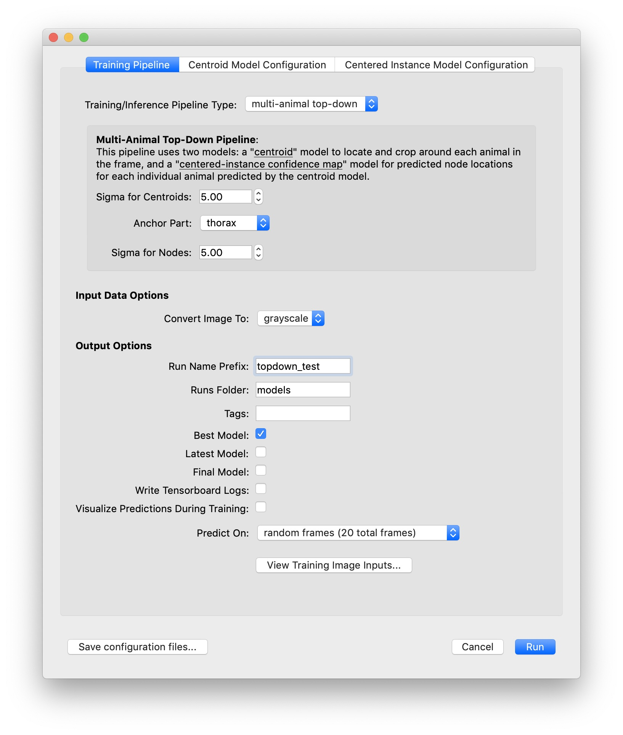
    - Repeat ii and iii for each additional animal in the frame.
    - Save your project labels by selecting File → Save As
- Once you have labeled 20 frames, you can train a rough model to make this process go faster.
  - Click on Predict → Run Training
  - Under training pipeline: select
    - Sigma for centroids = 5.00
    - Anchor Part = mid_center
    - Sigma for nodes =5.00
    - Convert image to= grayscale
    - Only click Best Model under output options. If you select Visualize predictions your training will go very slow.
    - Predict on: random frames
      - If you start with 3 videos this option will be random frames (60 frames total).
  - Under Centroid Model Configuration
    - Set the # of epochs to 3 and batches to 4
  - Under Centered Instance Model Configuration
    - Set the # of epochs to 10 and batches to 4
  - Now select Run. If using a GPU this should take 5min, otherwise it will take around 40min.
- Once the model is trained, begin to correct the predicted labels (marked with the thin black line on the timeline). To quickly navigate between labeled frames, use Alt + right arrow key or Alt + left arrow key.
  - For each frame, correct the node placement by drag each node into the correct position. It might be really off after the first iteration, but this will get better with more labeling.
  - Check there is the correct # instances in each frame (2 if doing RI). If the program picks up a non-animal instance, delete it.
  - Take a note of where the model is extra bad and add in more labels to frames similar to it.
- Repeat steps 6 and 7 once or twice. The skeleton should be getting better with each iteration, which you can gauge by viewing the training metrics (under Predict) or with the amount of adjustments you have to make with the nodes.
- Once you have a rough model established, focus more on the areas it is failing and train it more fully (default hyperparameters; this takes ½ day).
  - Do not label more than 1% of frames in 1 video.
  - Areas of failure tend to be when animals are overlapping and side to side.
  - Correct the predicted frames.
  - Repeat step 9 until you are done making corrections with the model. Be careful to not overtrain the model.
- Infer predictions on the whole videos and begin proofreading.
  - Things to look for:
    - Correct # of instances
    - If tracklets get swapped
- If you are happy with the results, you now have a model to generate tracklets!

SIMBA
- Must use custom configuration if acquiring
  - >2 animals (3+)
  - More labels that in default (4, 7, or 8)
  - Video longer than 20min at 30 fps

Pulling from SLEAP Github

